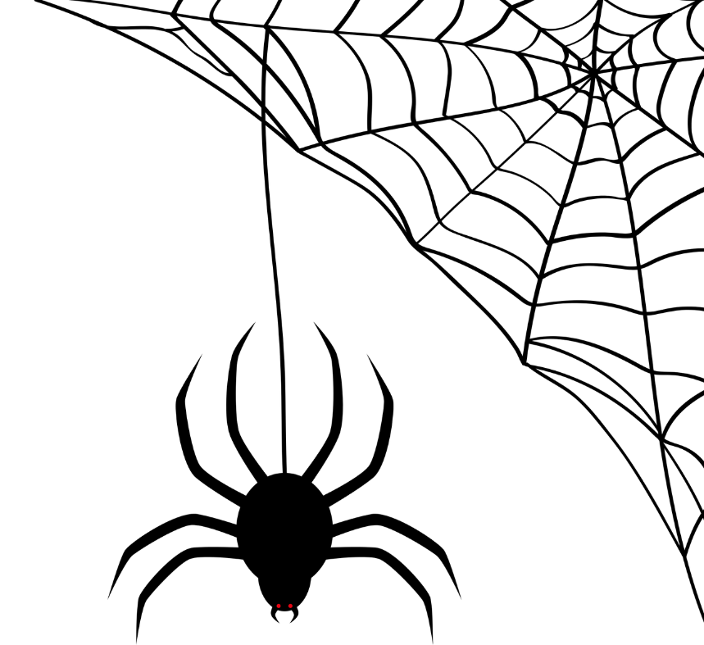



Shop*Eat*Trick-or-Treat!

TRICK-OR-TREAT
At The Streets of Tanasbourne
Sunday, October 29th
From 3:00 – 6:00 PM

0BSTREETS OF

1BTANASBOURNE
Instagram Station!!
SHOP, EAT, AND TRICK OR TREAT!!

